SIMPLE WIND-BLOWING INSTRUMENT (STRAW FLUTE)

Materials
- 1 straw
- Tape
- Scissors

Steps
- Take the straw and flatten one end with your fingers.
- Use scissors to cut the flattened end into a point shape.
- Blow through the pointed end to make a sound.
- Cut small holes along the straw.
- Cover and uncover the holes with your fingers to change the sound.
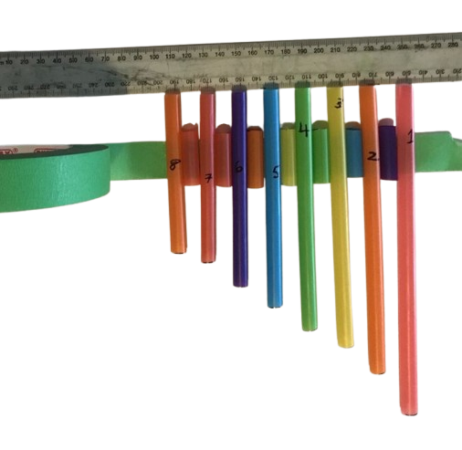
- Use tape to fix any cracks or decorate the instrument.

